Date:

Lab session no:

**Aim:**  a) Implement Hello World Program

b) Develop an android application to demonstrate Activity life cycle.

Example: Develop an android application that find's my age.

**Software’s /IDE Tools:**

Android Development Kit / Android Studio

**Application User interface design:**

**Code/Implementation:**

// Develop an android application to implement helloworld program

// Project Name : Testworld

/*

Lab Session No. : 01

Author : Eswar

Date : DD/MM/YYYY

Roll Number : 198W1A05E0

Description : Implementation of helloworld

Softwares required : Android Studio

Topics Covered :

*/

*MainAcitivity.java*

package com.eswar.testworld;  
  
import androidx.appcompat.app.AppCompatActivity;  
  
import android.os.Bundle;  
  
public class MainActivity extends AppCompatActivity {  
  
 @Override  
 protected void onCreate(Bundle savedInstanceState) {  
 super.onCreate(savedInstanceState);  
 setContentView(R.layout.*activity_main*);  
 }  
}

*activity_main.xml*

*<?*xml version="1.0" encoding="utf-8"*?>*<androidx.constraintlayout.widget.ConstraintLayout xmlns:android="http://schemas.android.com/apk/res/android"  
 xmlns:app="http://schemas.android.com/apk/res-auto"  
 xmlns:tools="http://schemas.android.com/tools"  
 android:layout_width="match_parent"  
 android:layout_height="match_parent"  
 tools:context=".MainActivity">  
  
 <ImageView  
 android:id="@+id/imageView"  
 android:layout_width="wrap_content"  
 android:layout_height="wrap_content"  
 android:layout_marginStart="24dp"  
 android:layout_marginTop="192dp"  
 android:layout_marginEnd="16dp"  
 app:layout_constraintEnd_toEndOf="parent"  
 app:layout_constraintHorizontal_bias="0.47"  
 app:layout_constraintStart_toStartOf="parent"  
 app:layout_constraintTop_toTopOf="parent"  
 app:srcCompat="@drawable/andriod_studio_logo" />  
  
 <TextView  
 android:id="@+id/textView2"  
 android:layout_width="wrap_content"  
 android:layout_height="wrap_content"  
 android:layout_marginStart="32dp"  
 android:layout_marginTop="91dp"  
 android:layout_marginEnd="32dp"  
 android:layout_marginBottom="200dp"  
 android:text="Welcome to andriod!Hello world"  
 app:layout_constraintBottom_toBottomOf="parent"  
 app:layout_constraintEnd_toEndOf="parent"  
 app:layout_constraintStart_toStartOf="parent"  
 app:layout_constraintTop_toBottomOf="@+id/imageView" />  
  
  
  
  
</androidx.constraintlayout.widget.ConstraintLayout>

b) *MainAcitivity.java*

package com.eswar.calculatemyage;  
  
  
import androidx.appcompat.app.AppCompatActivity;  
import android.os.Bundle;  
import android.view.View;  
import android.widget.Button;  
import android.widget.EditText;  
import android.widget.TextView;  
  
  
  
import java.util.Calendar;  
  
public class MainActivity extends AppCompatActivity {  
 EditText inputValue;  
 Button calculate;  
 TextView result;  
  
  
 @Override  
 protected void onCreate(Bundle savedInstanceState) {  
 super.onCreate(savedInstanceState);  
 setContentView(R.layout.*activity_main*);  
 inputValue=findViewById(R.id.*editTextInput*);  
 calculate=findViewById(R.id.*calculate*);  
 result=findViewById(R.id.*result*);  
 calculate.setOnClickListener(new View.OnClickListener(){  
 @Override  
 public void onClick(View view) {  
 int years = Calendar.*getInstance*().get(Calendar.*YEAR*);  
 String dobyear = inputValue.getText().toString().trim();  
 int dyear = Integer.*parseInt*(dobyear);  
 int age = years - dyear;  
 if (dobyear.isEmpty()) {  
 result.setText("Please Enter Input");  
 } else if (age < 0) {  
 result.setText("Enter a valid Input");  
 } else {  
 result.setText(String.*valueOf*(age));  
 }  
 }  
 });  
 }  
}

*activity_main.xml*

*<?*xml version="1.0" encoding="utf-8"*?>*<LinearLayout xmlns:app="http://schemas.android.com/apk/res-auto"  
 xmlns:tools="http://schemas.android.com/tools"  
 xmlns:android="http://schemas.android.com/apk/res/android"  
 android:layout_width="match_parent"  
 android:layout_height="match_parent"  
 android:background="@color/cardview_light_background"  
 android:orientation="vertical"  
 android:layout_gravity="center"  
 tools:context=".MainActivity">  
  
 <TextView  
 android:layout_width="wrap_content"  
 android:layout_height="wrap_content"  
 android:layout_gravity="center"  
 android:layout_marginTop="200sp"  
 android:text="calculate my age"  
  
 android:textColor="@color/cardview_dark_background"  
 android:textSize="20sp" />  
  
 <EditText  
 android:layout_width="wrap_content"  
 android:layout_height="wrap_content"  
 android:layout_gravity="center"  
 android:gravity="center"  
 android:layout_marginTop="100dp"  
 android:hint="Enter your year from DOB"  
 android:id="@+id/editTextInput"  
 android:minWidth="200dp"  
 android:height="40dp"  
 android:width="250dp">  
  
 </EditText>  
  
 <Button  
 android:layout_width="wrap_content"  
 android:layout_height="wrap_content"  
 android:layout_gravity="center"  
 android:gravity="center"  
 android:id="@+id/calculate"  
 android:text="Calculate Age"  
 android:background="@color/design_default_color_primary"  
 android:layout_marginTop="40dp"  
 android:minWidth="200dp">  
 </Button>  
 <TextView  
 android:layout_width="wrap_content"  
 android:layout_height="wrap_content"  
 android:layout_gravity="center"  
 android:layout_marginTop="50sp"  
 android:text="Your age is __"  
 android:id="@+id/result"  
 android:textColor="@color/cardview_dark_background"  
 android:textSize="20sp" />  
  
</LinearLayout>

**Output:**

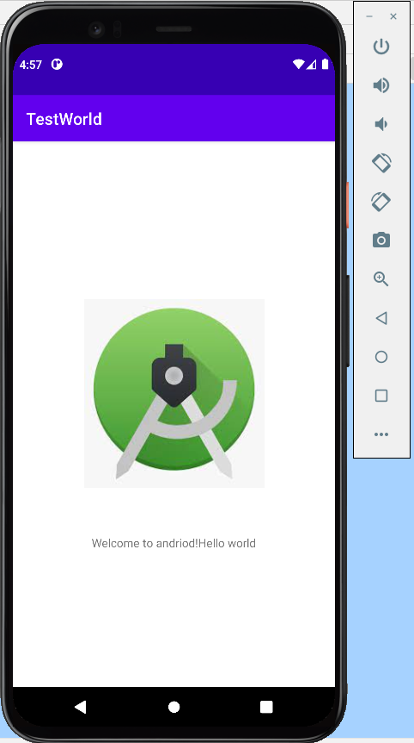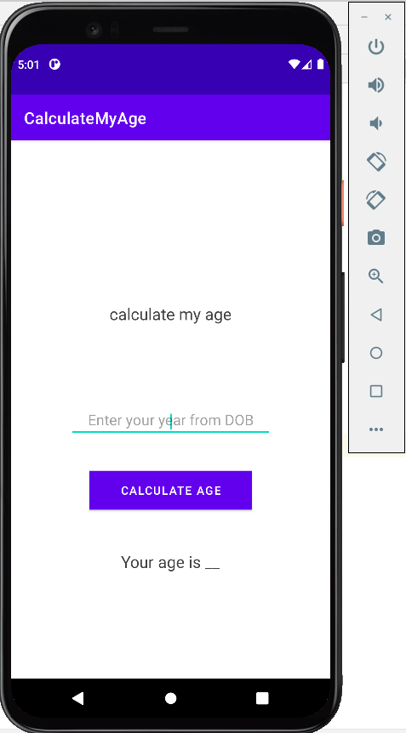

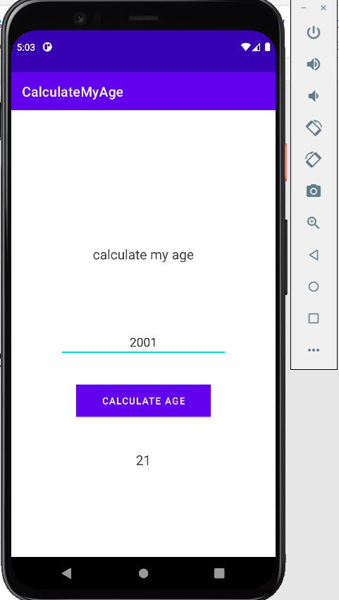

**Result:**

Implementation of helloworld application is done successfully